Record your pitch video

Requirments:
- Tool: Zoom
- Length of the video: 6 minutes
- Please record both yourself speaking and the PPT during your pitch
- Please add the contest’s official image to the first slide of your PPT before recording the video. The picture will be shared on May 18th 2021.
- Please upload it to your dedicated Drive folder, which has been shared with you earlier

Step 1: Launch your Zoom software, and start New Meeting

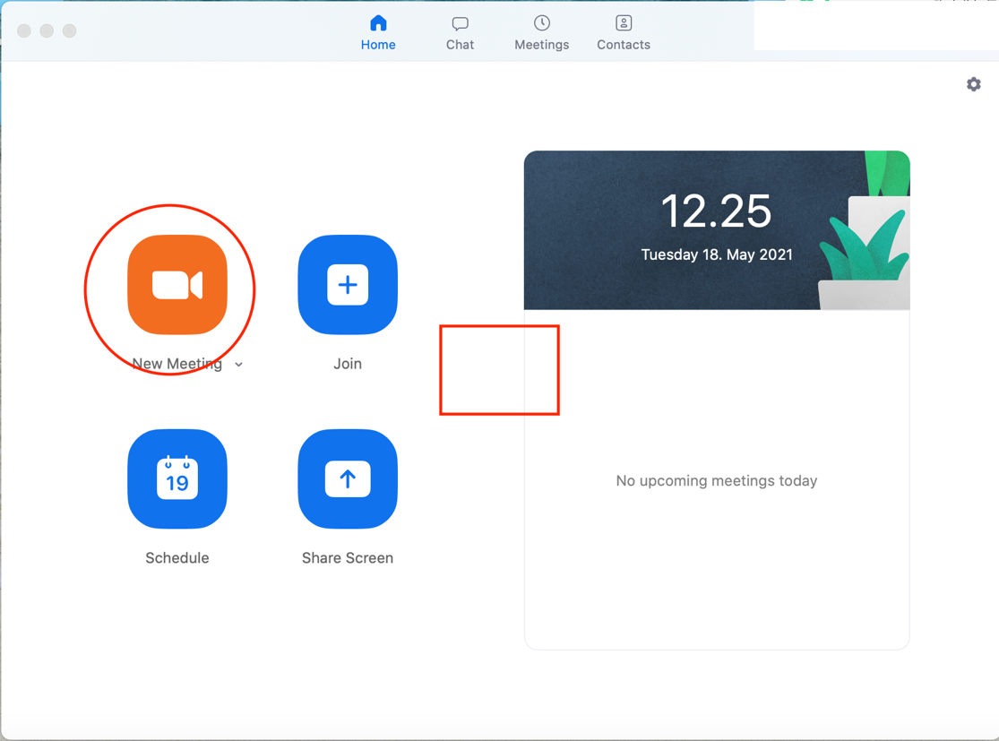

Step 2: Once you are in the meeting yourself, please make sure:
- Your microphone is on
- Your camera is on
- Your click Record button
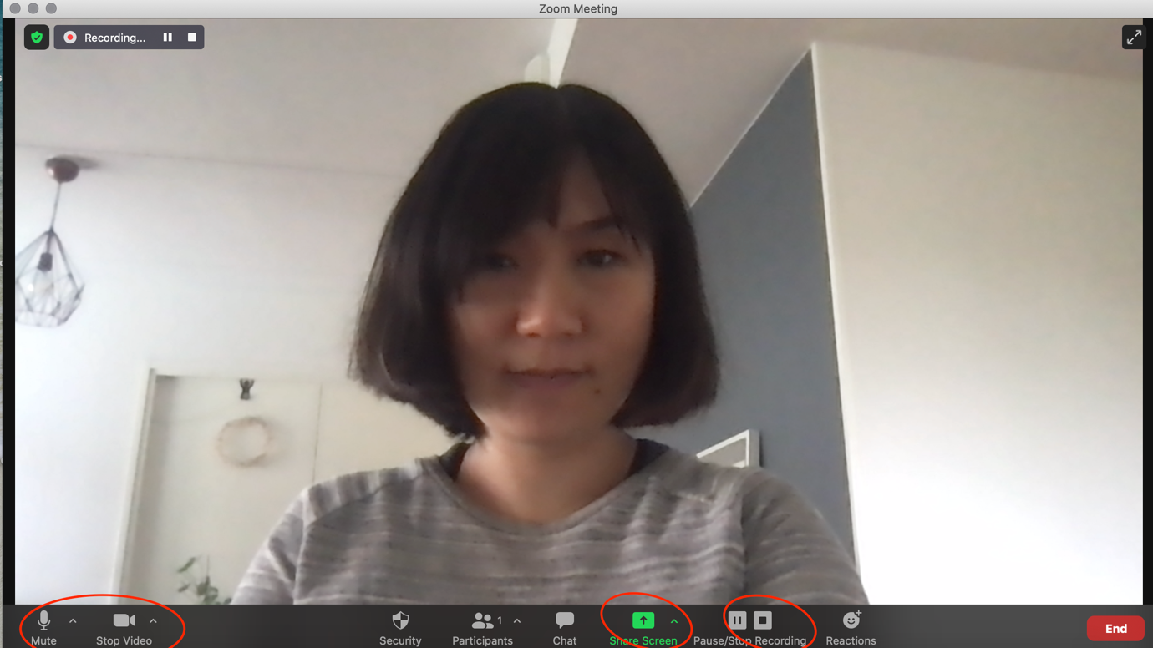

Step 3: When you are ready for pitch, please click Share Screen, and leave your PPT to full screen when you present.

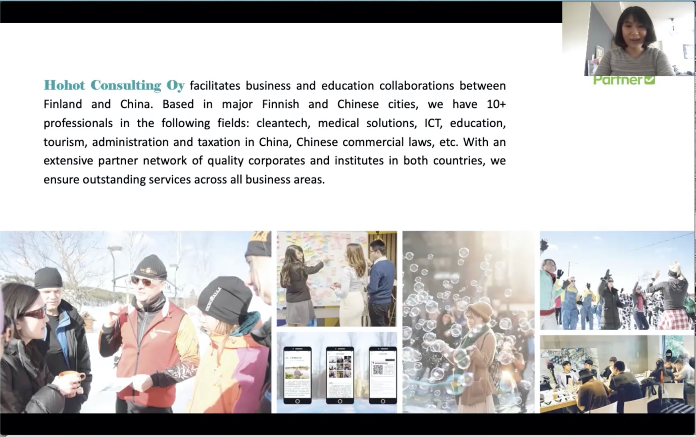

Step 4: After your 6-min pitch, your meeting recording (combining your pitch with your face and voice on and your controled PPT) will be saved on your computer.

